Note that this terminology often varies in the literature, especially with respect to the meaning of "complete" and "full". From: Wikipedia, http://en.wikipedia.org/wiki/Binary_tree
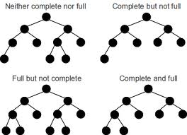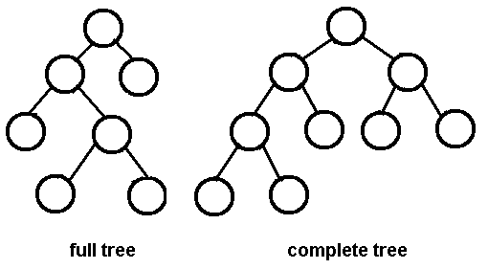
A full binary tree (sometimes 2-tree or strictly binary tree) is a tree in which every node other than the leaves has two children.^{[1]} ibid.
A complete binary tree is a binary tree in which every level, except possibly the last, is completely filled, and all nodes are as far left as possible.^{[3]} ibid.
A balanced binary tree is commonly defined as a binary tree in which the depth of the left and right subtrees of every node differ by 1 or less,^{[4]} although in general it is a binary tree where no leaf is much farther away from the root than any other leaf. (Different balancing schemes allow different definitions of "much farther".^{[5]}) ibid.
A degenerate (or pathological) tree is a tree where each parent node has only one associated child node. This means that performance-wise, the tree will behave like a linked list data structure. Ibid.
----------------------------------------------------------------------------------
Alternate definition: A binary tree is full if each node either is a leaf or has exactly two children.
(From http://courses.cs.vt.edu/~cs3114/Fall09/wmcquain/Notes/T03a.BinaryTreeTheorems.pdf)
Alternate definition: A binary tree T with n levels is complete if all levels (except possibly the last) are completely full, and the last level has all its nodes to the left side. (ibid.)
---------------------------------------------------------------------------------------
Alt/ 2: Nodes with no children are called leaves, or external nodes. Nodes not leaves are called internal nodes. From http://www.cs.cmu.edu/~adamchik/15-121/lectures/Trees/trees.html
A full binary tree is a binary tree in which each node has exactly zero or two children. Ibid.
A complete binary tree is a binary tree, which is completely filled, with the possible exception of the bottom level, which is filled from left to right.
A complete binary tree is very special tree, it provides the best possible ratio between the number of nodes and the height. The height h of a complete binary tree with N nodes is at most O(log N). Prove this by counting nodes on each level, starting with the root, assuming that each level has the maximum number of nodes:
n = 1 + 2 + 4 + ... + 2^{h-1} + 2^{h} = 2^{h+1} - 1
Solving this with respect to h, we obtain: h = O(log n) Ibid.

